**A COLLEGE FOOD CHOICES CASE STUDY USING TABLEAU**

**Lifestyle Overview:**

This dashboard provides a Lifestyle Overview of students, showcasing gender and marital status, employment types, GPA distribution, and perceptions of life rewarding experiences.

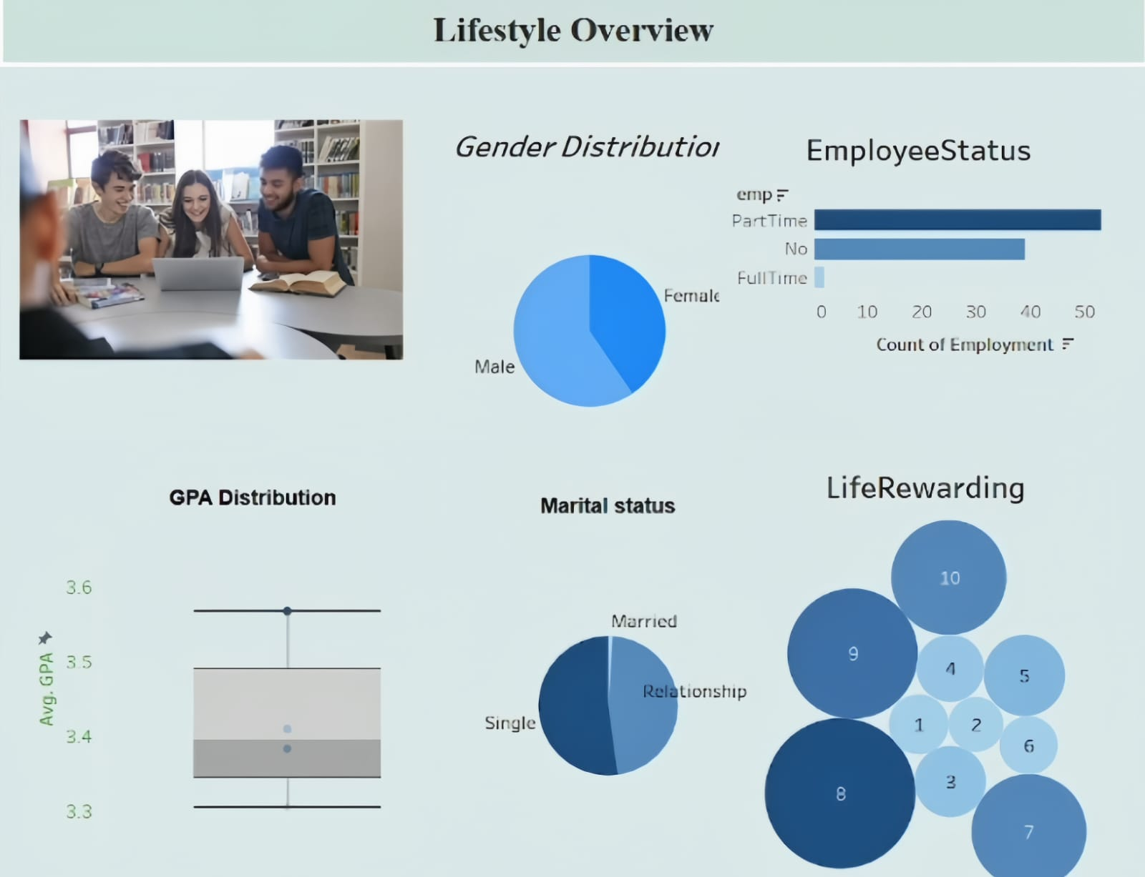

**Dietary Habits and Preferences:**

This dashboard highlights students' dietary habits and preferences, covering calorie awareness, diet status, comfort food reasons, cuisine choices, breakfast habits, and favourite sources of comfort food.

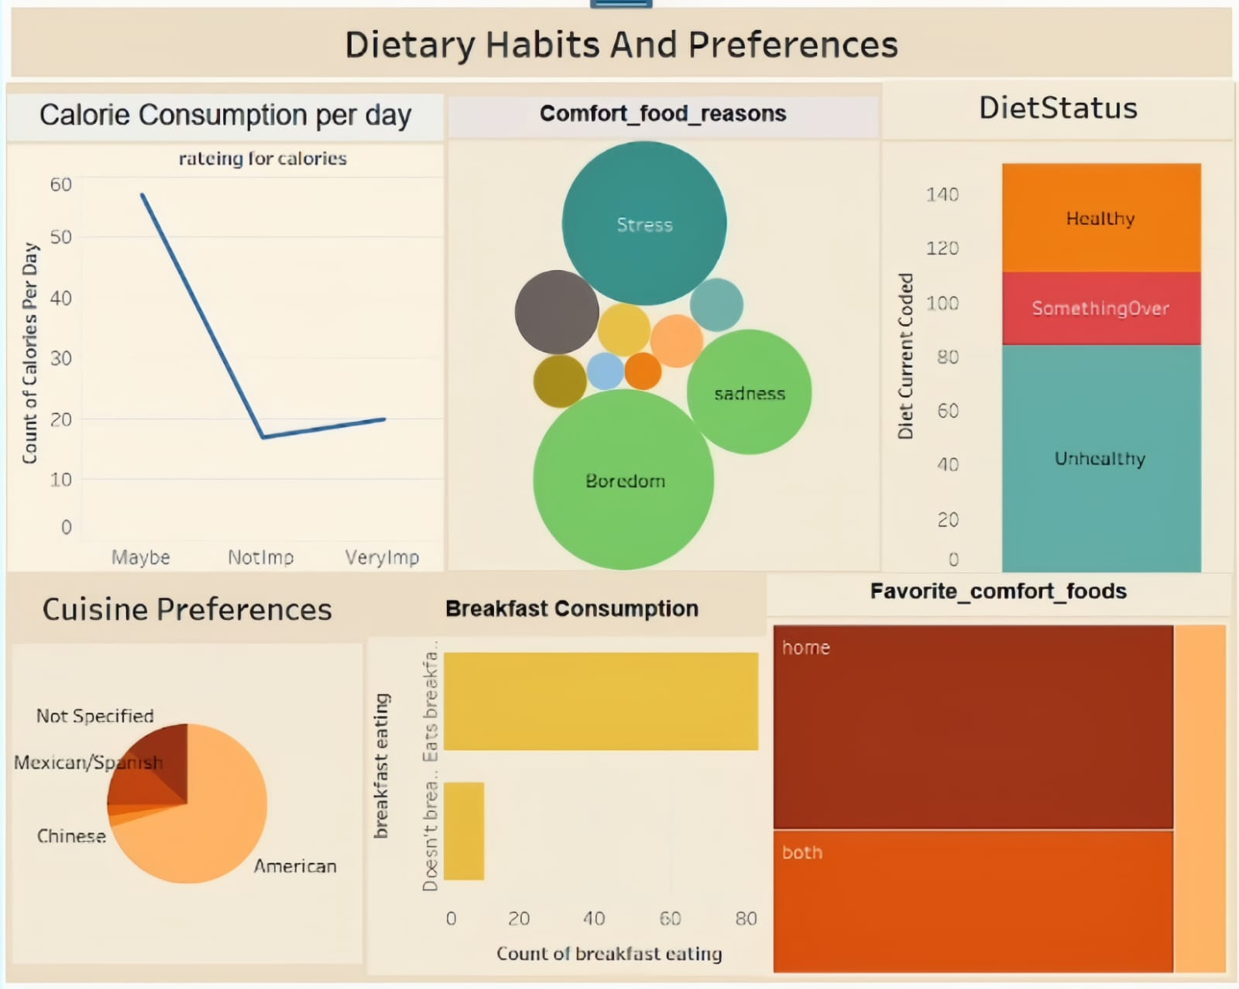

**Dietary Habits and Preferences:**

This dashboard explores students' dietary wellness through exercise frequency, vitamin intake by gender, fruit and veggie consumption patterns, nutritional awareness, and their self-perceived healthy feeling.

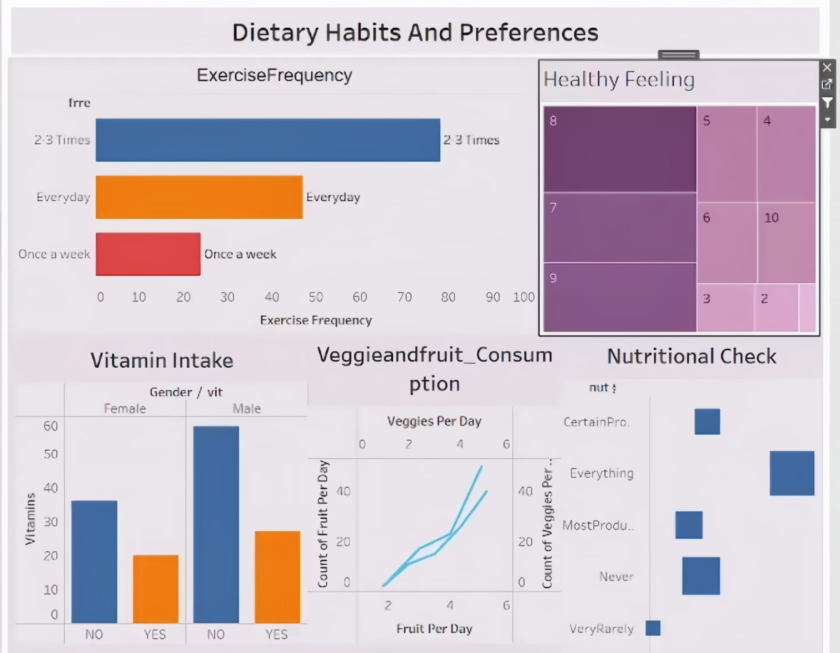

**Impact of Childhood Food Preferences on Audit Choices:**

This pie chart reflects the influence of childhood cuisine preferences on adulthood choices, with American cuisine being the most favoured, followed by Mexican/Spanish and unspecified options.

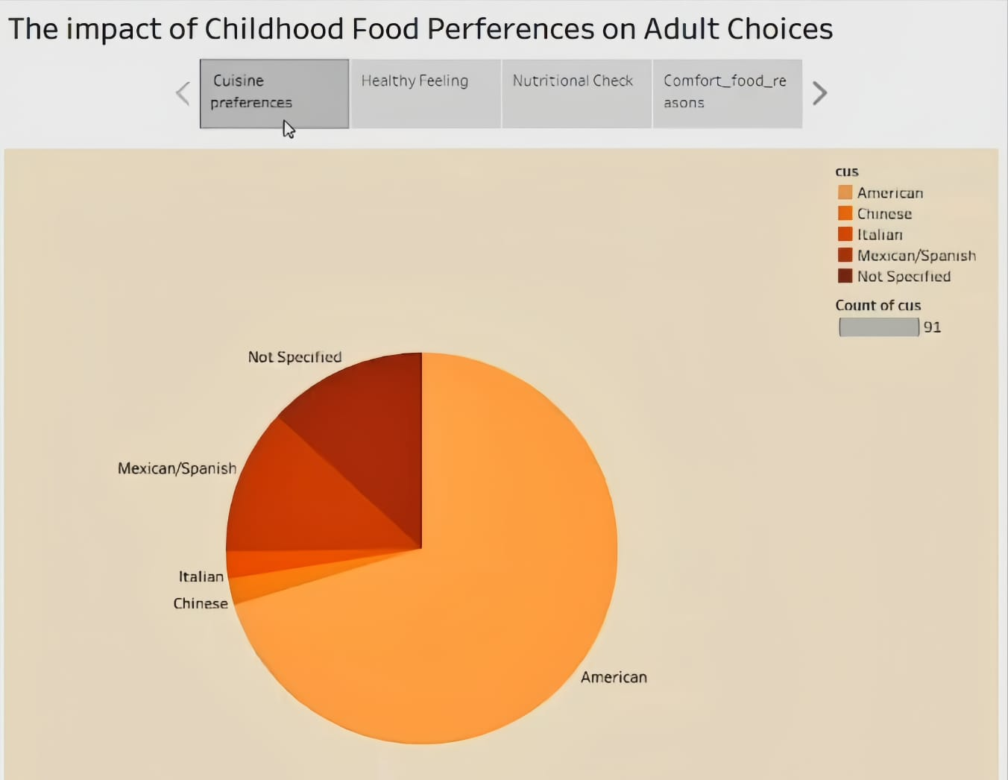

**Impact of Childhood Food Preferences and Adult Choices:**

This treemap illustrates how individuals perceive their overall health, with varying degrees of healthy feelings shaped by early dietary experiences.

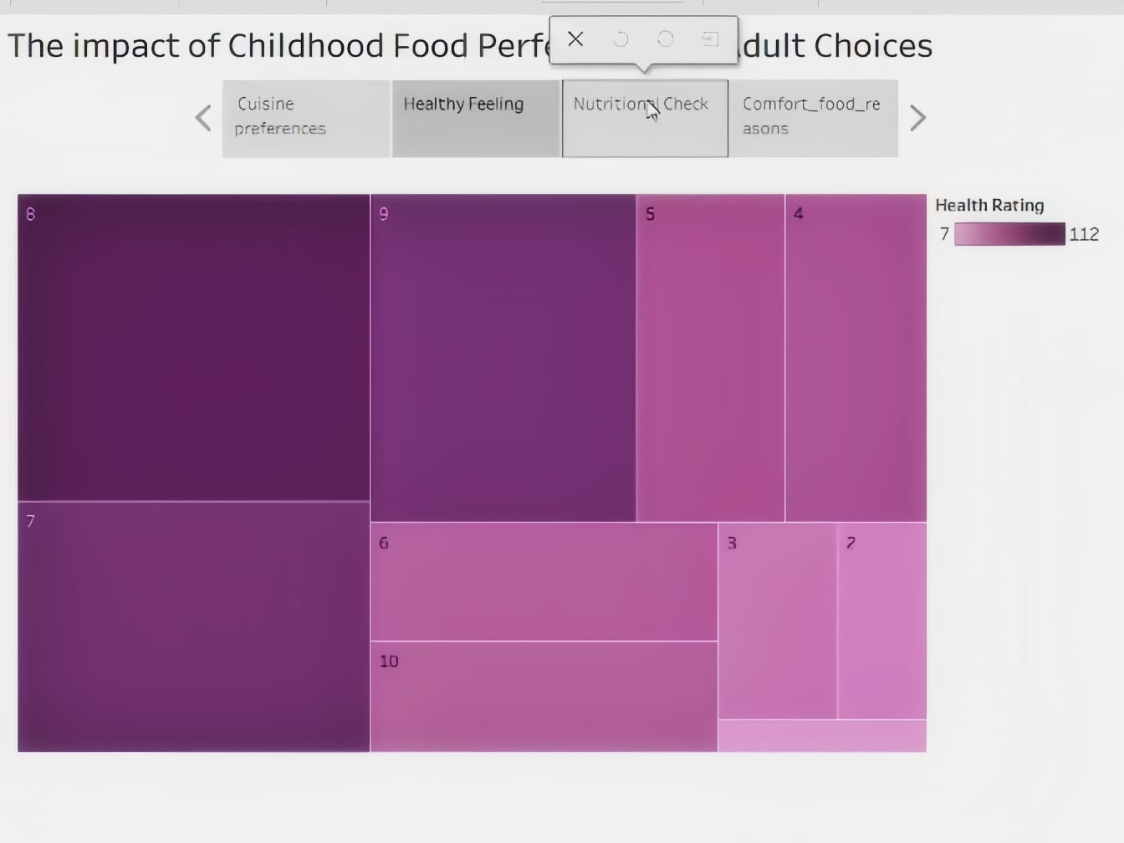

**Impact of Childhood Food Preferences on Adult Choices:**

This visualization shows the frequency of nutritional awareness in adults, linked to childhood eating habits—ranging from never checking to consistently monitoring food nutrients.

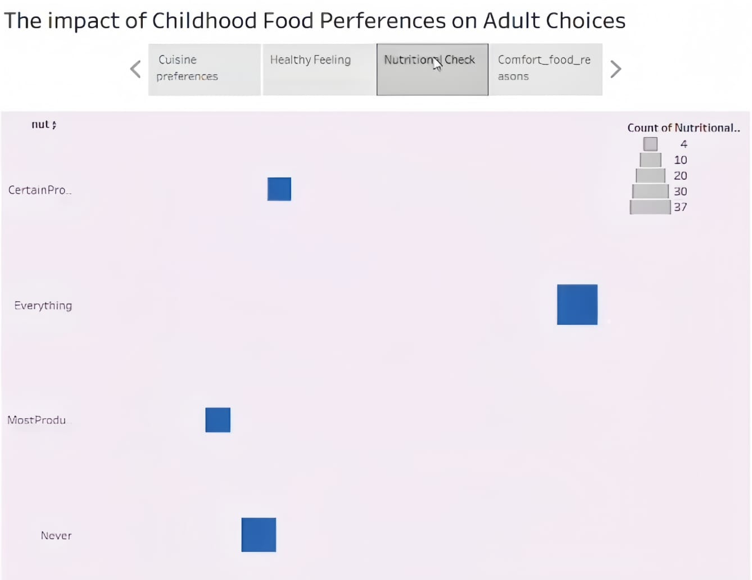

**Comfort Food Reasons:**

This bubble chart highlights emotional triggers behind comfort food consumption in adulthood—such as boredom, stress, sadness, and happiness—rooted in childhood associations.

